***Resume***

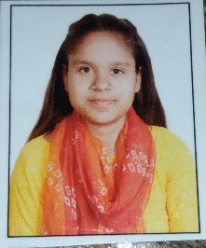

SANA SIDDIQUI

Address - 1062, Taj Compound, Nandanpura , Jhansi 284003 (U.P.)

E-mail: sanakhan300407262@gmail.com

Contact No.:+91-8112303702

**Mobile** : +91 9522113566 , 8827502625

**Email** : angelishu2610@gmail.com

Career-Objectives:

To have a dynamic career, that give me a chance to grow economically and psychologically by exercising my knowledge and abilities in the best interest in the ever- changing corporate scenario.

Educational Qualifications:

* Pursuing B.tech from IPS college.
* Intermediate from MP Board in 2021.
* High-School from UP Board in 2018

Experience :

2 Years experience of teaching.

6 Months experience as a sales executive.

Personal Profile:

* Father’s Name - Mr. Mohd.Aziz
* Mother’s Name - Late Smt. Shama
* Date Of Birth - 06/06/2002
* Gender - Female
* Marital Status - Unmarried
* Nationality - Indian
* Strengths - Honesty, Leadership quality, Confident, Punctual ,Sincere &Hard- Working.
* Skills - Computer knowledge, problem solving,
* Languages Known :- Hindi, Urdu & English.

Declaration:

All the above information given by me are true to the best of my knowledge &belief.

**Date:**  Yours sincerely,

**Place: ……………… Sana Siddiqui**